
RAMAIAH
Institute of Technology
USN | 1 | M | S

(Autonomous Institute, Affiliated to VTU)
(Approved by AICTE, New Delhi & Govt. of Karnataka) Accredited by NBA & NAAC with ‘A’ Grade

MAKEUP EXAMINATIONS – JUNE/JULY 2018

Course & Branch | : | B.E. : CS/IS | Semester | : | IV
Subject | : | Engineering Mathematics - IV | Max. Marks | : | 100
Subject Code | : | CS/IS41 | Duration | : | 3 Hrs

Instructions to the Candidates:
- Answer one full question from each unit.

 |  | UNIT- I
1. | a) | Write Simpson’s 3/8th rule. | CO1 | (02)
 | b) | Solve: 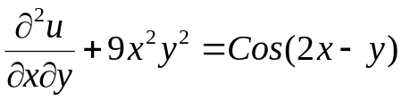 given that u=0, when y=0 and 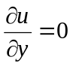when x=0. | CO1 | (04)
 | c) | The following table gives the temperature in degrees centigrade of a cooling body at different instant of time in seconds.  Find the rate of cooling at 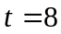 and 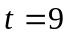seconds. | CO1 | (07)
   | 1 | 3 | 5 | 7 | 9
   | 85.3 | 74.5 | 67 | 60.5 | 54.3
 | d) | Given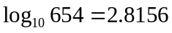, 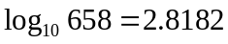, 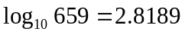and 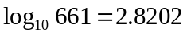.Find the value of 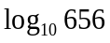using Newton divide difference formula. | CO1 | (07)
2. | a) | Write the Inverse Lagrange’s interpolation formula. | CO1 | (02)
 | b) | Solve 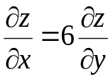 by the method of separation of variables. | CO1 | (04)
 | c) | Using an appropriate interpolation formula to find the value of y(1.4) from the following data: | CO1 | (07)
  x | 1 | 2 | 3 | 4 | 5
  y | 10 | 26 | 58 | 112 | 194
 | d) | Find an approximate value of 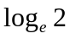 by applying Simpson’s 1/3rd rule to the integral 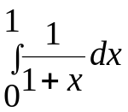using eleven ordinates. | CO1 | (07)
 |  | UNIT- II
3. | a) | Define types of random variable with an example each. | CO2 | (02)
 | b) | If x is an exponential variate with mean 5, evaluate (i) 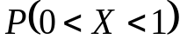 (ii) 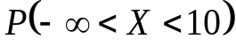 (iii) 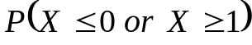 | CO2 | (04)
 | c) | A random variable X has the following probability function:  Find (i) k (ii) P(X ≥ 6) (iii) P(1 ≤ X < 5) (iv) E(X) (v) V(X). | CO2 | (07)
  X | 1 | 2 | 3 | 4 | 5 | 6 | 7
  P(X) | k | 2k | 2k | 3k | k² | 2k² | 7k²+k
 | d) | Stating the assumptions derive Poisson distribution as a limiting case of the binomial distribution. Also find mean and variance of the Poisson distribution. | CO2 | (07)
4. | a) | Define Binominal distribution and write its mean and variance. | CO2 | (02)
 | b) | Buses arrive at a specified stop at 15 min intervals starting at 7 A.M., that is, they arrive at 7, 7:15, 7:30, 7:45 and so on. If a passenger arrives at the stop at a random time that is uniformly distributed between 7 and 7:30 A.M., find the probability that he waits (i) less than 5 min for a bus and (ii) at least 12 min for a bus. | CO2 | (04)
 | c) | In a normal distribution, 7% are under 35 and 89% are under 63. Find the mean and the standard deviation, given that A(1.23) = 0.39 and  A(1.48) = 0.43 in the usual notation. where A(t) is the area under the standard normal curve from 0 to t. | CO2 | (07)
 | d) | The diameter of an electric cable is assumed to be a continuous  random variable with pdf 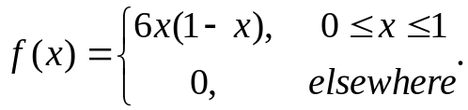 Verify that f(x) is a p d f. Also find its mean and standard deviation. | CO2 | (07)
 |  | UNIT- III
5. | a) | Define Ergodicity. | CO3 | (02)
 | b) | The joint probability density function of a two-dimensional random variable is given by 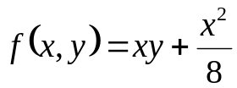,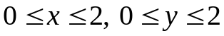 . Compute: (i) 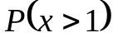 (ii) 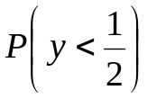. | CO3 | (04)
 | c) | A fair coin is tossed three times. Let X denote 0 or 1 according as the head or tail occurs on the first toss. Let Y denote the number of heads which occur. (i) Find the marginal distributions of X and Y, (ii) determine the joint distribution of X and Y and (iii) Cov(X,Y). | CO3 | (07)
 | d) | Find the ACF of the stochastic process defined by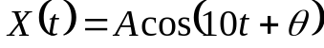 where A is a random variable with mean 0 and variance 1 and θ is uniformly distributed in the interval 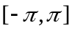. | CO3 | (07)
6. | a) | Define Auto correlation. | CO3 | (02)
 | b) | The joint probability density function of X and Y is given by:  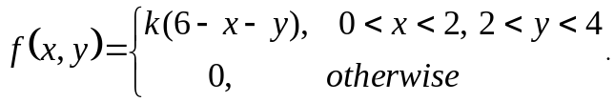 Find the value of k. | CO3 | (04)
 | c) | Consider a stochastic process defined on a finite sample space with three sample points. Its description is provided by the specifications of the three sample functions.  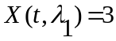, 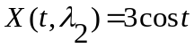,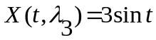. Also given the probability of the assignment 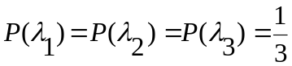, compute μ(t) and R(t₁, t₂). Decide whether the process is SSS or WSS. | CO3 | (07)
 | d) | Two cards are selected at a random from a box which contains five cards numbered 1, 1, 2, 2 and 3. Find the joint distribution of X and Y where X denotes the sum and Y, the maximum of the two numbers drawn. Also determine Cov(X, Y) and (X, Y). | CO3 | (07)
 |  | UNIT- IV
7. | a) | Define Absorbing state and Recurring state. | CO4 | (02)
 | b) | Arrivals at a telephone booth are considered to be Poisson with an average time of 10 minutes between one arrival and the next. The length of a phone call is assumed to be distributed exponential with 3 minutes. What is the probability that a person arriving at the booth will have to wait? | CO4 | (04)
 | c) | A salesman’s territory consists of three cities A, B & C. He never sells in the same city on successive days. If he sells in city A, then the next day he sells in city B. However, if he sells in either B or C, then the next day he is twice as likely to sell in city A as in other city. In the long run how often does he sell in each of the cities? | CO4 | (07)
 | d) | There are 2 white marbles in bag A and 3 red marbles in bag B. At each step of the process, a marble is selected at random from each bag and the 2 marbles selected are interchanged then i) find transition probability matrix of the markov chain, ii) What is the probability that there are 2 red marbles in A after 3 steps. | CO4 | (07)
8. | a) | Define M/G/1 queuing system. | CO4 | (02)
 | b) | Find the fixed probability vector of:  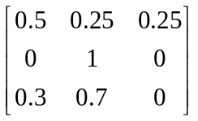. | CO4 | (04)
 | c) | Two boys b₁ and b₂ and two girls g₁ and g₂ are throwing a ball from one to the other. Each boy throws the ball to the other with probability ½ and to each girl with probability ¼. On the other hand, each girl throws the ball to each boy with probability ½ and never to the girl. In the long run, how often does each receive the ball? | CO4 | (07)
 | d) | Automatic car wash facility operates with only one boy. Car arrives according to a Poisson distribution, with a mean of 4 cars per hour and may wait in the facility’s parking lot if the boy is busy. If the service time for all cars is constant and equal to 10 minutes determine E(m), E(n), E(T) and E(w). | CO4 | (07)
 |  | UNIT- V
9. | a) | Define Type I and Type II errors. | CO5 | (02)
 | b) | A coin is tossed 400 times and returned heads 216 times. Test the hypothesis that the coin is unbiased. | CO5 | (04)
 | c) | A group of 10 rats fed on a diet A and another group of 8 rats fed on a different diet B recorded the following increase in weights in gms.  Test whether the diet A is superior to diet B. | CO5 | (07)
  Diet A | 5 | 6 | 8 | 1 | 12 | 4 | 3 | 9 | 6 | 10
  Diet B | 2 | 3 | 6 | 8 | 1 | 10 | 2 | 8 | - | -
 | d) | Two independent samples of sizes 7 and 6 have the following values:  Examine Whether the samples have been drawn from normal  population having the same variance? | CO5 | (07)
  Sample A | 28 | 30 | 32 | 33 | 33 | 29 | 34
  Sample B | 29 | 30 | 30 | 24 | 27 | 29 | -
10. | a) | Test the equality of standard deviations for the data given below at 5% level of significance: n₁=10 ; n₂=14 ; s₁=1.5 ; s₂=1.2 | CO5 | (02)
 | b) | A certain stimulus administered to each of the 12 patients resulted in the following change in blood pressure. 5, 2, 8, -1, 3, 0, 6, -2, 1, 5, 0, 4. Can it be concluded that the stimulus will increase the blood pressure? | CO5 | (04)
 | c) | Five Coins are tossed 320 times. The number of heads observed is given below. Examine whether the coin is unbiased. | CO5 | (07)
  No. of heads | 0 | 1 | 2 | 3 | 4 | 5 | Total
  Frequency | 15 | 45 | 85 | 95 | 60 | 20 | 320
 | d) | A population consists of the four numbers 3, 7, 11, 15. Consider all possible samples of size 2 which can be drawn without replacement from this population. In this case find (i) the population mean (ii) the population standard deviation (iii) the mean of the sampling distribution of means (iv) the standard error of means. | CO5 | (07)

****************

